

|  |
| --- |
| **GUIDANCE FOR THE SUBMISSION**  **OF REGULATORY INFORMATION IN eCTD FORMAT** |

|  |
| --- |
| This guideline is intended to provide recommendations to applicants wishing to submit applications for the registration of medicines in eCTD format. It reflects the current situation and will be regularly updated with changes in legislation and experience gained. It is important that applicants adhere to the administrative requirements to avoid delays in the processing and evaluation of applications.  Guidelines and application forms are available from the office of the Authority and the website. |

|  |  |
| --- | --- |
| First publication released for pilot implementation and comment | March 2013 |
| Version 2 published for implementation | September 2016 |
| Version 2.1 published due to administrative corrections | April 2017 |
| Version 3 change from MCC to SAHPRA (draft for public comment) | May 2019 |

**TABLE OF CONTENTS**

ABBREVIATIONS AND ACRONYMS 4

DEFINITIONS 6

1 INTRODUCTION 7

2 PURPOSE AND SCOPE 7

2.1 Types of products 7

2.3 Additional information and subsequent submissions 7

2.4 Submission formats of applications in eCTD format 8

3 STRUCTURE AND CONTENT OF SUBMISSIONS IN eCTD FORMAT 9

3.1 Structure 9

3.1.1 eCTD Identifier 9

3.1.2 Sequence number folder 10

3.1.3 Util and DTD subfolders 11

3.1.4 Module 1 subfolder 11

3.1.5 Modules 2 to 5 subfolders 11

3.1.6 Module 3.2.R 11

3.1.7 Leaf Titles 12

3.2 eCTD envelope 13

3.3 Metadata 13

3.4 Inclusion of correspondence documentation 14

3.5 Letter of Application 14

4 TECHNICAL REQUIREMENTS FOR SUBMISSIONS 16

4.1 Submission media 16

4.2 Compression and password protection/security settings 16

4.3 PDF files 17

4.4 File naming conventions 17

4.5 Hyperlinks and Bookmarks 18

4.6 MD5 checksum 18

4.7 Additional files in Word format. 19

4.8 Virus check 20

4.9 Validation 20

4.9.1 Categories of Validation Rules 22

4.9.2 Validation Process 22

4.10 Handling of thumbs.db files 22

5 LIFE CYCLE MANAGEMENT (LCM) 23

5.1 Life cycle management at the “Pharmaceutical Product” layer (eCTD application) 23

5.2 Life cycle management at the submission layer (i.e. eCTD-sequence) 23

5.3 Life cycle management at the document layer (eCTD leaf) 23

5.4 Life cycle management of specific documents 23

5.5 Responses to Recommendations 24

5.6 Tabulated Schedule of Amendments 24

6 BASELINE SUBMISSIONS 25

7 SUBMISSION 26

8 UPDATE HISTORY 27

9 APPENDICES 28

Appendix 1: eCTD Reference Documents 28

Appendix 2: List of documents requested additionally in paper format 29

# ABBREVIATIONS AND ACRONYMS

API Active Pharmaceutical Ingredient

CD Compact Disc

CD-ROM Compact Disc Read-Only Memory

CTD Common Technical Document

DTD Document Type Definition

DVD Digital Video Disc

eCTD electronic Common Technical Document

eSubmission electronic Submission

EMA European Medicines Agency

EU European Union

EWG Expert Working Group

FPP Finished Pharmaceutical Product

HCR Holder of Certificate of Registration

ICH International Council for Harmonisation (of Technical Requirements for Registration of Pharmaceuticals for Human Use)

INN International Non-proprietary Name

IPI Inactive Pharmaceutical Ingredient

ISO International Standards Organisation

IT Information technology

LCM Life cycle management

MCC Medicines Control Council

MD5 Message-Digest algorithm 5

OCR Optical Character Recognition

PDF Portable Document Format

PHCR Proposed Holder of Certificate of Registration

PI Professional Information

PIL Patient Information Leaflet

Q&A Question and Answer documents

RAR RoshalARchive

SAHPRA South African Health Products Regulatory Authority

Swissmedic Swiss Agency for Therapeutic Products

ToC Table of Contents

Util Utility folder in the eCTD Sequence. Contains technical files

XML Extensible Markup Language

ZA/SA South Africa

# DEFINITIONS

Application number: The application number is the official reference number assigned to the dossier or eCTD application by the Authority. It remains with the dossier for its full life cycle and also in archiving.

Dossier: A collection of documents compiled by an applicant/PHCR in compliance with South African legislation and guidelines in order to seek registration of a medicine, or any amendments thereof. An application may comprise a number of submissions.

eCTD application: A collection of electronic documents compiled by an applicant/PHCR in compliance with South African legislation and guidelines in order to seek registration of a medicine, or any amendments thereof. An eCTD application may comprise a number of eCTD Sequences. In South Africa an eCTD application may comprise several strengths, each with a unique proprietary name. Such a collection may also be described as a dossier.

eCTD identifier: An eCTD identifier is the application number used as the directory name in the top-level directory.

eCTD Sequence: All files and folders in a submission in eCTD format are to be placed under the eCTD-Sequence number folder (equivalent to the term "sequence" used by the EMA)

eCTD Submission: An eCTD Submission is an electronic-only submission in the eCTD format that is supported by paper documents (e.g. some documents from Module 1).

eSubmission: An electronic Submission that follows the CTD format

Regulatory activity: A regulatory activity is a logical entity of submission activity (for example a new indication) with a defined start and end point (e.g. initial submission to final approval). In the eCTD world, a regulatory activity consists of all the eCTD Sequences that together make up the lifecycle of that particular regulatory activity.

It can also be defined as a collection of sequences covering the start to the end of a specific business process, e.g. an initial application for registration or a type C variation. It is a concept used to group together several business related sequences.

Submission / Sequence: A single set of information and/or documents supplied by the applicant/PHCR as a partial or complete application. In the context of eCTD, this is equivalent to ‘eCTD Sequence’.

Technical validation: The technical validation is a validation by an automated tool, checking the DTD and other technical components of the eCTD. Two categories of validation rules apply: “Pass/Fail (P/F)” and “Best Practice (BP)”.

# 1 INTRODUCTION

This guideline provides recommendations to applicants on electronic submissions with the electronic Common Technical Document for the Registration of Medicines (eCTD). It is to be used in the preparation and submission of applications for registration of medicines to SAHPRA in the eCTD format established by the International Council for Harmonisation (ICH) of Technical Requirements for Registration of Pharmaceuticals for Human Use.

The relevant guidance on the same topic, issued by EMA, Swissmedic and SAHPRA, have been considered in the preparation of this document and were used as a basis.

eCTD is the preferred format for submission to the South African Regulatory Authority. eSubmissions will be accepted by the authority for a limited period of time. Please refer to the General Information Guideline for more detail.

Applicants who submit an application in the eCTD format must comply with the requirements for such submissions; these are

* the requirements defined in this guideline
* the South African Specification for eCTD Module 1
* the Electronic Common Technical Document Specification (current version), developed by the ICH M2 Expert Working Group (EWG)
* the South African eCTD validation criteria

This guidance document is supplemented by the questions and answers document (2.28 Q&A on Implementation of eCTD in South Africa), which is updated on a regular basis. In addition, further eCTD Q&A issued by the ICH can be found at http://estri.ich.org/eCTD/index.htm.

**Timelines**

Refer to the General Information Guideline for details on the digital submission implementation roadmap.

# 2 PURPOSE AND SCOPE

The purpose of this guideline is to integrate the eCTD format within the SAHPRA registration framework by describing the electronic format requirements for applications for registration of medicines submitted in accordance with the Medicines and Related Substances Act, 1965 (Act 101 of 196), as amended, and the regulations thereto.

## 2.1 Types of products

This guideline applies to all human medicines (pharmaceutical and biological).

It does not apply to veterinary medicinal products or complementary medicines.

## 2.2 Additional information and subsequent submissions

Once an applicant submits an application in the eCTD format, all responses to recommendations, additional information and amendments for the same medicine should be submitted in the eCTD format (“once eCTD, always eCTD”). Applicants should not revert to the paper-based CTD format for subsequent submissions for the same medicine.

If an applicant decides to not submit an application in eCTD format, the only alternative is to submit in eSubmission format. Applicants should switch from eSubmission to eCTD at the start of any new regulatory activity. However, applicants cannot change from eCTD to eSubmission.

## 2.3 Submission formats of applications in eCTD format

The eCTD is intended as an electronic only submission.

For legal reasons however distinct documents of Module 1 such as listed in Appendix 2 have to be submitted also as signed original paper versions.

The paper version is to be arranged in the same order as the electronic version. An electronic copy declaration should be submitted in Module 1.2.2.4 to confirm that the paper versions are identical to the PDF versions included in the eCTD. As it is a declaration, it must be signed and dated and indicate the relevant sequence.

The current SAHPRA practices have to be taken into account to define which documents are needed for the submission types, and the documents detailed in Appendix 2 should be provided where applicable.

Please refer to other SAHPRA guidelines relating to applications for registration.

# 3 STRUCTURE AND CONTENT OF SUBMISSIONS IN eCTD FORMAT

## 3.1 Structure

The content of information required for submissions in eCTD format is the same as for paper-based submissions in CTD format. However, the location of files in the submission in eCTD format may differ from the location of the paper documents in the submission in CTD format.

The eCTD structure reflects the XML backbone that is used for the submission.

The eCTD structure can be graphically displayed by an XML viewing tool. Figure 1 illustrates a portion of the eCTD structure, as seen using an XML viewing tool.

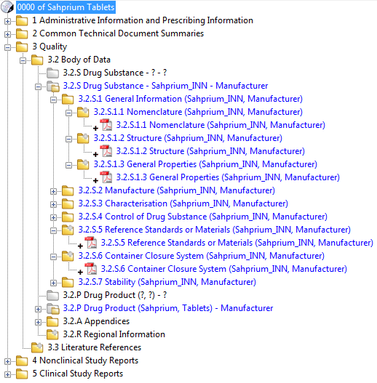

Leaf File

Module 3 Subfolder

Sequence Number Folder

Figure 1

### 3.1.1 eCTD Identifier

The application number is to be used for the top-level directory (root directory). This will be the unique identifier for the application. In the case of multiple applications[1] the application number of the master application should be used as the eCTD identifier.

The applicant has to send a written request on the official company letterhead to the Authority for the attention of Operations & Administration with details of the application(s) to be submitted using the working code “eCTD AGC”. The request has to be submitted at least eight weeks before the intended date of submission, to allow for four weeks for processing at the Authority. The proposed proprietary name/s and the type of data to be submitted in support of safety and efficacy should be indicated in the request.

The application number(s) will then be issued and will be valid for a period of four weeks. If the application is not submitted within four weeks, the applicant should submit a reason for the delay and request for an extension of the validity. Alternatively, the number may be cancelled and the applicant may have to apply for a new number.

Details of the name used for the root directory should always be included in the letter of application. The new application and subsequent submissions must use the same top-level directory name, e.g. /470001-3/0000

/470001-3/0001

*See Figure 2*

### 3.1.2 Sequence number folder

All files and folders in a submission in eCTD format are to be placed under the sequence number folder, as described in the ICH Electronic Common Technical Document Specification, “File Names and Directory Structure”.

The sequence number folder should be named using a four-digit number. The sequence number for the first submission should be 0000. Applicants are to provide an incremental number, unique within the same application for each new sequence they provide.

If a submission fails technical validation due to a technical error, the sequence number does not change when the application is submitted again.

If the submission passes technical validation, but has content deficiencies, resolving these deficiencies requires an increment to the sequence number.

The sequence number folder includes an m1 subfolder, m2–m5 subfolders (optional), and a *util* subfolder (see Figure 2) as well as the eCTD backbone file (index.xml), and the checksum file (index-md5.txt).

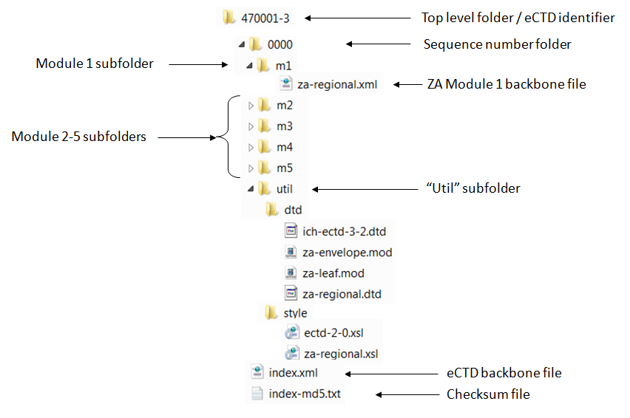

Figure 2

### 3.1.3 Util and DTD subfolders

The *util* subfolder contains a *dtd* subfolder as well as a style subfolder and they must only contain the files that are mentioned in the South African Specification for eCTD Regional Module 1.

### 3.1.4 Module 1 subfolder

The content of the Module 1 is described in detail in the South African Specification for eCTD Regional Module 1.

### 3.1.5 Modules 2 to 5 subfolders

The structure and content of the Modules 2 to 5 subfolders (m2–m5) are defined in the ICH Electronic Common Technical Document Specification.

The following points are to be considered:

* Node extensions are allowed but should be used only where necessary.
* Node extensions are necessary for each clinical study report. The leaf title for the node extension should serve as study identifier, containing study number and appropriate study title. If clinical study reports consist of several PDF files, the leaf title of each file should indicate its content (e.g. “synopsis”, “main body”).
* STFs from submissions in the US are not required but a submission will not be rejected if they are included.

### 3.1.6 Module 3.2.R

An enhanced granularity is required in this module. The granularity should be built with Node Extensions and Subfolders including numbering of the subfolders. Further information can be found in the South Africa eCTD Validation Criteria on the tab “File-Folder Structure & Names”.

See Figure 3 for an example.

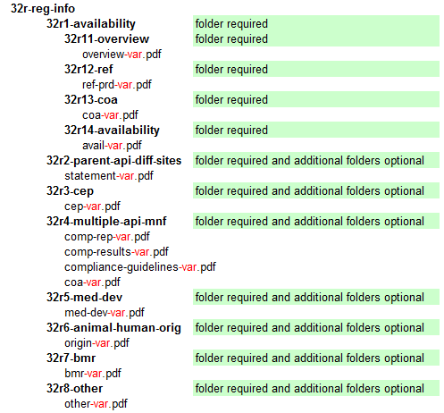

Figure 3

The structure of Module 3.2.R can be graphically displayed by an eCTD viewing tool.

See Figure 4 for an example.

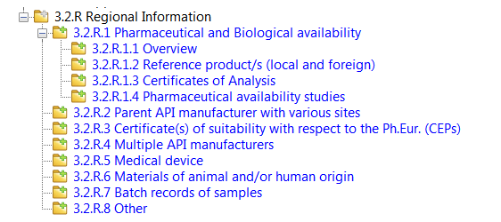

Figure 4

The lack of the required granularity in Module 3.2.R may cause a rejection of the eCTD due to non-compliance with business validation.

### 3.1.7 Leaf Titles

Leaf titles are an important part of eCTD submissions, as they are displayed to the evaluator when evaluating an eCTD application. Including meaningful information in leaf titles makes submissions easier to navigate and facilitates the evaluator’s task.

The leaf titles should be short, meaningful and indicative of the document’s content, so that someone who isn’t familiar with the application would know what the document is from the leaf title without having to open the document.

Leaf titles should be suitably descriptive for the current sequence and all possible lifecycle sequences.

See Figure 5 for examples (as seen using an XML viewing tool)

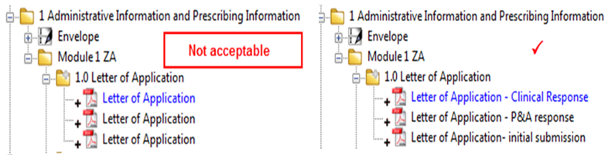

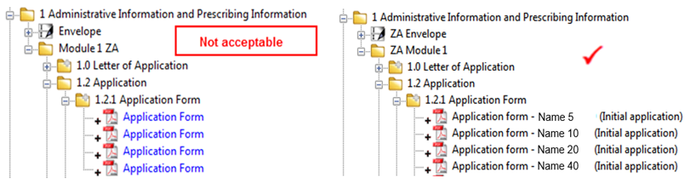

Figure 5

Both the PDF file name and the leaf title are used to identify and describe each file in the eCTD. The leaf title does not have to be the same as the file name given to the PDF file.

The PDF file name is seen if navigation through the dossier is done via a direct view of the files and folders.

The leaf title is displayed / seen if the XML backbone and stylesheet or a dedicated eCTD review tool is used to navigate through the submission.

Examples:

|  |  |
| --- | --- |
| *File name:* | Leaf title: |
| Application-letter.pdf | Letter of application (Initial application) |
| pi.pdf | Proposed Professional Information initial application |
| avail.pdf | Comparative dissolution study report |

## 3.2 eCTD envelope

The metadata provided by the applicant with the eCTD are extremely important, since it indicates relationships between individual sequences for effective lifecycle management of the application.

The particular envelope elements used by the review tool for display and management of submissions are listed in the South African Specification for eCTD Regional Module 1, Appendix 2.

Applicants must include and present metadata in a manner that unequivocally ties them to a submission (e.g. applicant name, INN). It is appreciated that there may be legitimate reasons for the metadata in the envelope to change over the lifecycle of the product and this is technically supported. Consistency, quality and accuracy of metadata should always be assured.

The application number must be included in the envelope. In the case of multiple applications, the application numbers and proprietary names should be included as follows:

* application number: master application
* proprietary name: master application
* multiple applications: name/s and application number/s of duplicate application/s

## 3.3 Metadata

The leaf attribute metadata provided by the applicant is considered important, since this information is displayed by review tools and is used for identifying documents and sections, and becomes particularly important in managing the lifecycle of the submission. For example, the ICH eCTD Specificationdescribes six eCTD Heading Element Attributes for use in the eCTD to structure the eCTD content. Five of these attributes are in Module 3:

* Substance (API)
* Drug Product (FPP)/Drug Substance (API) Manufacturer
* Product Name
* Dosage Form
* Excipient (IPI)

These attributes correspond to elements in the eCTD that may be repeated, and are used to define specifically what each repeated section covers.

For example, in an eCTD covering two active ingredient manufacturing sites, the directory structure for the eCTD may be split into two paths which will contain documents for the different sites, and the XML will be similarly structured (see the ICH eCTD Specification).

The extent to which a single eCTD can cover multiple substances, manufacturers, product strengths and excipients, and the use of these attributes to describe what is being covered is largely left to the applicant.

This means that the eCTD can be structured in different ways. These potential variations in structure and scope can affect the presentation of the dossier using eCTD review tools that ‘read’ the XML, and affect eCTD repositories that are used to store the eCTD files and directory structure.

The structure of an eCTD will affect how the lifecycle of the eCTD can be managed over time, and, therefore, the structure of the first eCTD for a product or product range needs careful consideration. For example, if an eCTD is built to cover 100 mg and 200 mg tablets, and common documents are submitted for both strengths, if a line extension is introduced to add a 150 mg tablet, then the applicant needs to decide whether to replace 100/200 mg documents with a 100/150/200 mg document, or to create a new standalone 150 mg document and introduce another 2.3.P and 3.2.P section to the existing eCTD. Another option would be to build an entirely different and new eCTD for the 150 mg tablets. Different dosage forms, e.g. tablets and injections, have to be separate dossiers.

## 3.4 Inclusion of correspondence documentation

The term ”correspondence” applies to all communications (documents) that are exchanged between an applicant and the authority in the context of an regulatory activity but which do not have a formal designated placeholder within the eCTD structure. For example, responses to SAHPRA questions are not classified as ‘correspondence’ since the ZA M1 eCTD DTD includes a designated section for such information, see section 5.5.

Not all correspondence should be included in the eCTD. This is because the eCTD exchange is currently one way only (from the applicant to the authority), and not all correspondence is directly relevant to the dossier. Accordingly, only the minimum of correspondence that relates directly to the content of the dossier should be included in submissions to SAHPRA, added as an annex to the letter of application in Section 1.0. An example of applicable correspondence would be committee recommendations.

All other correspondence should be exchanged outside the eCTD via the usual means.

## 3.5 Letter of Application

Submissions as well as additional information in eCTD format should be accompanied by an administrative letter of application in both paper and portable document format (PDF). A template of the letter provided by SAHPRA should be used.

The PDF should be a scan of the originally signed document and must be searchable (OCR scanned).

This letter should always state the context of the submission, e.g. the submission type and the application or registration number.

The paper and PDF letters must have the same content.

The letter of application in the submission in eCTD format is located in the folder 1.0 of the ZA Module 1. The letter of application has no lifecycle and should therefore always be submitted with the document operation attribute “new”. As eCTD viewing tools will display all “new” leaf elements in a current or cumulative view, additional descriptive text has to be included in the leaf title to assist with identification of specific letters. This will help identify each letter of application leaf and the submission it is in, rather than having the letters named the same in each sequence.

Some examples for the leaf titles could be:

Letter of application for Initial Application

Letter of application for New Indication AML

In case of a technical rejection, the replacement sequence needs to include the original letter of application of the rejected sequence in Module 1.0 in addition to the new letter of application for the replacement sequence. The leaf titles of both cover letters should be named clearly.

The letter should at least contain the following information:

* Date
* The applicant’s name and address
* The proprietary name(s)
* Registration number or Application number
* Dosage form
* Dosage strength(s)
* The International Non-proprietary Name(s) (INN) of the product
* The submission type
* A description of the submission
* Number of CDs/DVDs provided
* Contact details in case of technical validation issues
* Name and version of eCTD validation tool used to check compliance with the specifications
* The working code as according to the General Information guideline. The working code should be preceded by eCTD, e.g. “eCTD ANA”.

Refer also to the Guidance for the Submission of the South African CTD /eCTD - General &Module 1.

The following statement must be included:

* “We confirm that the CD/DVD-burning session is closed and the submission is checked with an up-to-date and state-of-the art virus checker: [name of the antivirus software and version of the virus checker] and is virus-free".

The tracking of the submitted sequences in a tabular format should be included as an annex to the letter, as per the following example:

|  |  |  |  |  |  |
| --- | --- | --- | --- | --- | --- |
| **Date of submission** | **Sequence number** | **Submission type** | **Related eCTD sequence** | **Regulatory activity/ Submission description** | **Regulatory status**  **(submitted / approved / rejected** |

The letter (paper version) must be signed.

If there are specificities concerning the eCTD submission about which the reviewers should be informed, it is highly recommended to include as an annex to the letter an eCTD ”Reviewer’s Guide”, that may contain the following sections if applicable, in addition to those specified above:

* Legacy documents and scanned pages details
* Files referenced at multiple locations within the backbone
* Specifications adhered to
* Documents with relevance to more than one CTD-module
* Hyperlink appearance and strategy (screenshot showing what hyperlink looks like)
* Bookmarks
* Particulars of module organisation, e.g. the strategy for the presentation of Modules 2.3.S / 3.2.S and 2.3.P / 3.2.P
* List of documents available on request

# 4 TECHNICAL REQUIREMENTS FOR SUBMISSIONS

## 4.1 Submission media

Hard media (e.g. CD-ROMs, DVD-ROMs) must be used for the submission of all eCTDs.

CD (CD-ROM) conforming to ISO 9660 or ISO 13346 can be accepted.

SAHPRA will not accept any hardware (laptops, desktops, zip drives, etc.) from applicants in connection with the submission of information in electronic format. The electronic information or eCTD should be directly readable and usable on SAHPRA’s hardware (e.g. CD/DVD drive) using its own software. It is the policy of SAHPRA to maintain desktop configurations and IT infrastructure in line with common office standards.

The use of re-writable disks is not encouraged. When using re-writable disks, all open sessions must be closed before sending the CDs/DVDs.

In the case of a large application, provision of a single DVD over multiple CDs is strongly recommended by SAHPRA, as this allows the technical validation and loading into the repository directly from the hard media, without the need to first recompile the eCTD submission on a server.

If the provision of a single CD or DVD is not possible, and if multiple CDs must be used for large applications, individual modules should not be split over multiple CDs (e.g. if possible, Module 1 should be contained on a single CD, Module 2 should go onto the next CD even if this requires CD 1 not to be filled to capacity and so on). Where a split over multiple CDs is inevitably necessary, subfolders should be distributed in sequence, and these subfolders should not be split between CDs. In this case the submission of a DVD should be considered.

The submission media should be packed adequately to prevent damage to the media. All the contained media units should be appropriately labelled as described below.

Each CD or DVD submitted with an eCTD should include the following label information, clearly presented and printed on the media:

* The applicant’s name
* The proprietary name(s)
* The registration number or application number
* The International Non-proprietary Name(s) (INN) of the product
* The sequence number of the eCTD submissions contained on the CD/DVD
* The submission date (MM-YYYY)
* The Number of CDs or DVDs per full set and an indication of the place of the individual CD/DVD within this set
* The submission type of each eCTD submission(s) contained on the CD/DVD, as per the eCTD envelope information.

## 4.2 Compression and password protection/security settings

The applicant is required not to apply any compression to the submission or the files inside the submission. Therefore, the data on the media should not be packed into a zip-file, rar-file or any other file format that has been compressed.

One-time security settings or password protection of electronic submissions for security purposes is not acceptable during transportation from the applicant to SAHPRA. Applicants should also not include any file level security settings or password protection for individual files in the eCTD. The file settings should allow printing, annotations to the documents, and selection of text and graphics. Internal security and access control processes in the regulatory authority will maintain the integrity of the submitted files.

Encryption is not considered necessary if the information is sent using a physical media. The applicant should assume all responsibility for the media until it is delivered to SAHPRA.

The following points should be noted in relation to security:

* The physical security of the submission during transportation/transmission is in the responsibility of the applicant.
* Once received by SAHPRA, security and submission integrity is the responsibility of the authority.

The use of, and subsequent validation of the MD5 checksum allows the recipient of the eCTD to ascertain whether files in the submission have been changed since the checksum was generated.

## 4.3 PDF files

Portable Document Format (PDF) is an electronic format that is open, *de facto*, and published and created by Adobe Systems Incorporated (http://www.adobe.com). No specific products from Adobe or any other company are necessary to produce PDF documents.

The following points can be made in relation to PDF files:

* Files should be PDF v1.4, 1.5, 1.6 or 1.7 and should be legible with the Acrobat Reader search plug in or any other freeware viewer; PDF files should be saved as ”Optimised” to reduce the size and allow faster opening when viewed via an internet connection. The use of additional software to navigate and work with the files is not acceptable.
* PDF files produced from an electronic source document are preferred to PDF files generated from scanned paper since such 'electronic' PDF files provide the maximum functionality to the reviewers in terms of search capabilities and copy & paste functionality.
* Expert Reports and the Overviews/Summaries in the CTD Module 2 should preferably be generated from an electronic source document.
* If scanning is unavoidable, readability and file size should be balanced; the following is recommended: resolution 300 dpi (photographs up to 600 dpi), avoid gray-scale or colour where possible, use only lossless compression techniques. The file must be searchable (OCR scanned).
* The maximum individual acceptable file size is approximately 200 MB. If a file size exceeds 200 MB, the file should be split into two files. The file size should ensure clarity, speed of download and ease of review.
* Fonts should be chosen of a type, colour and size such that they allow easy reading of documents on screen (1024 x 768 pixels) or after printing. Refer to Guidance for the Submission of the South African CTD /eCTD - General & Module 1.
* All fonts used in a document (except Times New Roman, Arial and Courier) should be embedded, including all the characters for the font. The number of fonts used in a document should be limited and customised fonts be avoided. If colours other than black are used, colour reproduction after printing should be tested before submission; the print area for pages should fit on an A4 sheet of paper; margins should allow binding without affecting readability.

Additional details on PDF can be found in the ICH eCTD Specification.

## 4.4 File naming conventions

It is recommended to use the eCTD file naming conventions described in the ICH M2 eCTD Specification and the South African Specification for eCTD Module 1.

If an applicant wishes to submit multiple files in one section, where only one highly recommended name is available, this can be achieved using a variable suffix to the filename (e.g. pharmaceutical-development-container.pdf).

## 4.5 Hyperlinks and Bookmarks

In general, hypertext links are encouraged within the eCTD to facilitate swift navigation within the dossier, but should not be overused. The eCTD should be structured and links provided in such a way as to ensure that the reviewer is constantly aware of the overall structure and narrative flow of the dossier. For example, Module 3 is highly structured and defined to a relatively low level of granularity in the specification. Therefore, only minimal use of hyperlinks should be necessary, e.g. when the same citation appears on a page more than once, it is recommended that a link only to the first instance of the citation per page is provided.

Documents should be placed only once in the eCTD folder structure and referred to via hyperlinks.

The greater the number of hyperlinks contained in an eCTD dossier the greater the likelihood of non-functioning hyperlinks. The use of “obvious” and therefore redundant external links is discouraged with a view to future lifecycle management.

However, if hyperlinks are only to be included where considered necessary and considered to add real value, it is important that the way in which the eCTD titles are used (i.e. the backbone entries visible as the eCTD “ToC”) is consistent with how the documents themselves are referred to within other documents, for example summary documents. If the title presented by the review tool in the eCTD ToC and the reference in a summary document do not match, then this negates the use of the backbone and a hyperlink is needed.

In the Non-clinical/Clinical part of the eCTD, the structure is less well defined. Within Modules 4 and 5 the localisation of studies and references may vary across submissions. For fast orientation linking from summaries is of benefit. Since changes occur rarely to already-submitted content in Modules 4 and 5 in contrast to Modules 3 the issue of outdated links over the application lifecycle is therefore less critical.

Hyperlinks from the non-clinical and clinical overviews to the references themselves can be provided directly from the text or from the list of references at the end of the document. Missing hyperlinks may lead to a formal objection.

Broken links are technically classified as best practice criteria (BP). Even though a submission is technically accepted, content validation / evaluation may not be successful if hyperlinks or bookmarks are not functional to a critical extent, and the submission may be returned due to formal reasons.  
As a general conclusion, broken links in a summary document (e.g. preclinical overview) is more critical than broken links in a study appendix due to different frequencies with which these hyperlinks are used.

References should not contain external links (e.g. weblinks).

Within Modules 2 to 5, bookmarks are needed for documents exceeding five pages that contain multiple headings or sections, tables or figures, except for literature references where bookmarks are not necessary. In general, for documents with a table of contents, bookmarks for each item listed in the table of contents should be provided including all tables, figures, publications, other references, and appendices. For further information regarding the use of bookmarks please refer to the ICH eCTD Specification.

The cross-references in the Patient Information Leaflet in section 1.3.2 should be hyperlinked to the Professional Information (PI) in section 1.3.1.1 and the cross-references in the Professional Information in section 1.3.1.1 should be hyperlinked to the actual references only in sequence 0000.

The annotated and hyperlinked proposed professional information and patient information leaflet should be included in section 1.5.5 in subsequent submissions.

## 4.6 MD5 checksum

A checksum (MD5) should be included for each file in the eCTD, allowing the recipient to verify the integrity of physical files in the submission.

An MD5 checksum of the XML eCTD index (index.xml) should also be included. Applicants should name this checksum file index-md5.txt, and include it as a file in the same directory as the XML eCTD instance.

The MD5 checksum allows the recipient of the eCTD to ascertain whether files in the submission have been modified since the checksum was generated by the applicant.

An invalid checksum will result in the rejection of an eCTD submission as technically invalid.

The printout of the checksum file (index-md5.txt) should be attached as an annex to the letter (paper version). The annex must be dated and signed, and indicate the product name, application number and relevant sequence.

## 4.7 Additional files in Word format.

SAHPRA requires Word documents for the following documents, in addition to the PDF for the purposes of review and document manipulation:

* Module 1.2.1 Application form
* Module 1.3:

- Professional Information

- Patient Information Leaflet

- Label

* SCoRE document, appended to Module 2.2 Introduction
* Module 1.11 BTIF (Bioequivalence Trial Information Form)
* Module 1.11 Biowaiver template
* P&A reliance template

PDFs only are to be referenced in the eCTD XML backbone.

Word documents must not be included in the eCTD backbone, as they are provided merely as an aid to review.

Word files should be placed on the same data carrier, alongside the 0000 (or appropriate) eCTD sequence, not within it (see Figure 5). The folder should be called ““<eCTD sequence>workingdocuments” (e.g. 0000-workingdocuments)” with a substructure as follows:

* 0000-Application form
* 0000-Product information

Within this folder, for the following files in Word format, the following naming convention applies:

* For the Application Form

*af_productname_submissiontype_date.doc*

* For the package insert:

*pi_productname_submissiontype_date.doc*

* For the patient information leaflet:

*pil_productname_submissiontype_date.doc*

* For the label:

*label_productname_submissiontype_date.doc*

* For the SCoRE:

*score_productname_submissiontype_date.doc*

* For the BTIF:

*btif_productname_submissiontype_date.doc*

* For the biowaiver template:

*biowaiver_productname_submissiontype_date.doc*

* For the P&A reliance template:

*reliancetemplate_productname_submissiontype_date.doc*

* For the blank master batch manufacturing records

*bmbmr_productname_submissiontype_date.doc*

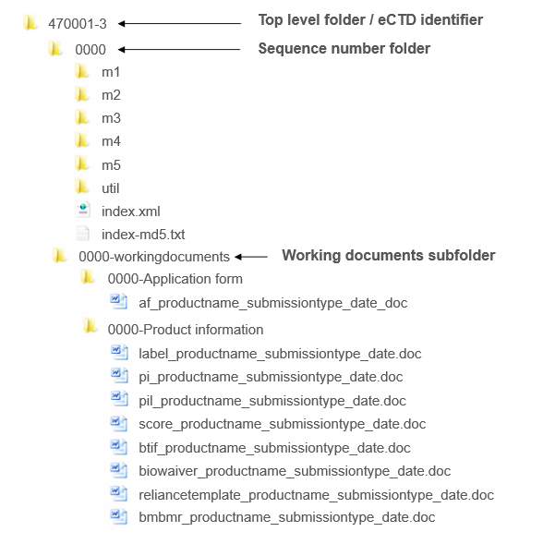

Figure 6

## 4.8 Virus check

The applicant is responsible for checking the submission for viruses and for informing SAHPRA of the type of software used for this purpose.

Checking should be performed with at least one, but preferably more, up-to-date virus checkers and a statement must be included in the letter of application (see section 3.5)

After receipt at SAHPRA an internal virus check will be performed. A positive check will result in the refusal of the eCTD.

## 4.9 Validation

The validation criteria serve to aid the applicant to carefully set up the eCTD. Refer “South African eCTD Validation Criteria”.

Applicants are required to create eCTD dossiers that are technically correct according to the South African Specification for eCTD Regional Module 1 and ICH eCTD Specification.

A technically correct eCTD submission is pivotal for a timely and successful review of the submission. Therefore it is the SAHPRA’s intention to accept technically correct eCTDs only, to minimize any delay that might affect the content validation and the review process.

Data and documents should be supplied in a uniform format to facilitate Life Cycle Management on all levels. The uniform format will further assist long term preservation and readability. Data and document consistency will assist the SAHPRA during the review process, enabling easier access and navigation and therefore simplifying the review process.

### 4.9.1 Categories of Validation Rules

- *Pass/Fail Criteria*

eCTDs that fail to meet one or more of the “Pass/Fail” criteria will not be processed and the applicant will be advised to rectify the problems and resubmit with the same sequence number.

* *Best Practice Criteria*

It is considered good practice to ensure that these validation criteria are correct in the submitted eCTD. The applicant should make every effort to address these areas before the eCTD is submitted. eCTDs that fail to meet one or more of these criteria may still be accepted by the authority during technical validation.

**Note:** Errors found during the content validation (evaluation) should be resolved through the submission of a new eCTD sequence. These errors must never be resolved by resubmitting an existing sequence.

### 4.9.2 Validation Process

Applicants must use an eCTD validation tool that checks the submission for technical interoperability before submission.

The applicant must submit a validation report identifying validation results including pass/fail and best practice. For any Best Practice criteria that are not met, the applicant must add a note to the submission in paper with a justification for the warnings.

SAHPRA will carry out the following process on receipt of an eCTD:

1. Administrative compliance check *(see section A.1 of the Validation Template)*
2. Technical validation: This will be performed in a single step *(see section A.2 of the Validation Template)*
3. Business validation: Content check *(see section A.3 of the Validation Template)*
4. Technical verification (*see sections B, C, D, E of the Validation Template*)

In case of technical validation issues, the application will be returned to the applicant with a report identifying issues to be corrected. The corrected sequence has to be submitted with the same sequence number.

If no technical validation issues are identified the eCTD will be imported into the review system for business validation and technical screening. The applicant will be notified of successful validation for the first sequence submitted (i.e. 0000). For follow-up sequences the applicant will only be notified if there are technical or business validation issues.

### 4.9.3 Validation template

The validation template details the validation process. The template should be completed by the applicant and submitted in M1.8.

## 4.10 Handling of thumbs.db files

It is possible that *thumbs.db* files are present among the eCTD files after having published the sequence.

*thumbs.db* files are system files created by Microsoft Windows every time a file is opened and are often not displayed in the Windows Explorer. In the context of an eCTD submission such files are unreferenced in the XML backbone and cause a validation error. SAHPRA will reject such eCTD sequences and will request a replacement sequence.

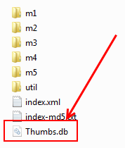

Figure 7

To avoid creating thumbs.db files, the applicant is advised not to open files or folders after publishing and before burning the sequence on CD. It is possible to disable thumbs.db files in Microsoft Windows. Please liaise with your IT department for support.

# 5 LIFE CYCLE MANAGEMENT (LCM)

## 5.1 Life cycle management at the “Pharmaceutical Product” layer (eCTD application)

An initial application is usually defined as having a sequence number of 0000. There are some circumstances in which an initial application might be submitted with a sequence number other than 0000.

Each further submission for the corresponding Pharmaceutical Product will be done with an incremental eCTD sequence number.

## 5.2 Life cycle management at the submission layer (i.e. eCTD-sequence)

The related eCTD sequence number describes the relationship of additional information to the first sequence of a regulatory activity. It allows sequences to be grouped together that make up an application or a regulatory activity.

For all new application and post-registration submissions types in eCTD format, the related eCTD-sequence number in the envelope and in the letter of application (tracking table) should be <none>.

For subsequent submissions (responses) that are related to another eCTD sequence, it is mandatory to include a related eCTD-sequence. The related eCTD-sequence number, a four-digit number, should be the sequence number of the submission to which the additional information applies.

See “Example of the use of the Related Sequence” in Appendix 2 of South African Specification for eCTD 1 Regional Module 1.

## 5.3 Life cycle management at the document layer (eCTD leaf)

The operation attribute describes the relationship between leaf files in submissions subsequent to the original submission and in additional information related to those submissions. (For an original submission only the operation attribute “new” is applicable).

The four LCM activities (operation attributes) provided by the ICH are new, replace, delete and append. Further information can be found in the ICH Electronic Common Technical Document Specification.

The operation “append” should not be used as it can cause problems in the further lifecycle of documents.

## 5.4 Life cycle management of specific documents

Responses to Recommendations and adaptations of labelling and packaging (Module 1.3) files are handled with new eCTD Sequences.

For life cycle management at the document layer, the operation attribute should be treated as described below for specific documents.

The operation attribute should always be “New” for the following leaf elements provided with all eCTD-sequences:

* 1.0 letter of application
* 1.2.1 application form
* 1.2.2.1 proof of payment
* 1.2.2.4 electronic copy declaration
* 1.5.2.1 tabulated schedule of amendments

For the application form leaf elements, the operation attribute may be “replace” only if it had to be corrected.

For the Labelling and Packaging Information (Professional Information, Patient Information Leaflet, Label) leaf elements:

* when provided with the initial application (sequence 0000), the operation attribute should be “New”
* when provided with all other submission types, the operation attribute should be “Replace” (exception: sequence 0000)
* when provided as additional information in response to the Committee Recommendations, the operation attribute should be “Replace”

## 5.5 Responses to Recommendations

When the original application is submitted in eCTD format, and where Recommendations have been issued by the SAHPRA, the responses must also be provided in eCTD format.

All the quality related recommendations and responses should be addressed in the Tabulated Schedule of Amendments in Module 1.5.2.1 (Amendments guideline).

Where responses also contain new or updated data/documents relating to Modules 3, 4 and/or 5, such data/documents should be placed in the relevant sections of those Modules. This may also apply to Module 1 (e.g. revised Labelling and Packaging Information), as well as to Module 2 in cases where extensive data/documents would require inclusion of the relevant summaries and/or overview sections.

## 5.6 Tabulated Schedule of Amendments

Where new or updated documents are required, hyperlink(s) from an appropriate location(s) in the Tabulated Schedule of Amendments to the new or updated document(s) elsewhere in the eCTD dossier should be included.

A Tabulated Schedule of Amendments is required for the following submission types:

Response to pre-reg recommendation:

* pre-reg-pa - Pharmaceutical and Analytical
* pre-reg-biol - Biological committee response
* pre-reg-cm - Complementary Medicines
* pre-reg-cr: Response to Authority resolutions

Post-registration:

* post-reg-pa: Pharmaceutical and Analytical
* post-reg-biol: Biologicals and biosimilars
* post-reg-cm: Complementary Medicines

Response to post-registration recommendation:

* resp-post-reg-pa: Pharmaceutical and Analytical
* resp-post-reg-biol: Biologicals and biosimilars
* resp-post-reg-cm: Complementary Medicines

# 6 BASELINE SUBMISSIONS

A baseline submission marks the change from a paper based submission to an eCTD submission.  
It provides a single source of information relating to a product in a technically valid, easily readable structure and sets a solid foundation (baseline) upon which the lifecycle (history of changes) of a product can be built in the new format.

It is highly recommended that an eCTD baseline submission is submitted in eCTD format for applications previously managed in paper. Baseline submissions should not be submitted during an ongoing regulatory activity. The baseline should always be a separate submission and should never include new applications.

There is no obligation to submit a full, reformatted eCTD for already registered products. The sections provided can be defined by the applicant, but any omissions should not render the submitted content misleading. However, the applicant should provide SAHPRA with information reformatted as eCTD for their already registered products for modules 1-3. In particular SAHPRA encourages the submission of reformatted quality information in eCTD, in order to facilitate the handling of amendments. Submissions of as much content as possible will realise the greatest and most timely benefit both within the applicant’s organisation and for the Authority.

The baseline submission should reflect the status most recently approved. A signed declaration must also be submitted in Section 1.2.2.4 stating that the content/data of the submitted modules in eCTD format is identical to the current approved documents and that there have been no changes to the dossier content as a result of the provision of an eCTD submission. It is not acceptable to exclude any information from the original dossier unless it has been updated by a regulatory process (e.g. amendment).

The baseline should preferably consist of high quality electronic source document, but good quality scanned images would also be acceptable in these cases, preferably with OCR to facilitate text searching.

In the majority of cases, an eCTD baseline submission will be provided as sequence 0000 for a product where there has been no previous eCTD submission. However, for a product with an ongoing lifecycle SAHPRA would also accept a baseline submission within the lifecycle.

Only a technical and business validation will be carried out on the eCTD sequence. There is no content validation and no evaluation process involved, and hyperlinks between documents are not required.

The envelope element *application type* for a baseline submission should be *baseline*.

A baseline always has to be submitted as a separate sequence. It is possible to submit a baseline sequence as a separate sequence together with an amendment.

The following has to be considered:

***Timing of the submission***:

* Preferred option: At the beginning of the transition from paper to electronic as sequence 0000
* For products with amendments planned for Module 3
* Before or with an amendment (of e.g. Module 3) BUT as a separate sequence.

When submitting changes to Module 3, it will be expected that in most cases the full section Drug Substance and/or Drug Product will be submitted. Exceptions (when such submissions will not be of added value) should be justified in the letter of application.

In principle, all CTD subheadings should be addressed. Statements justifying absence of data for specific CTD sections should be provided in the relevant Quality Overall Summary.

Placeholder documents indicating “no relevant content” should not be placed in the eCTD structure.

To reflect the status most recently approved, all the documents of Module 1 relevant to the registration need to be included into the baseline submission.

# 7 SUBMISSION

The paper copies and the hard media should be submitted jointly.

The eCTD on DVD/CD should be submitted to SAHPRA at the following address:

The Chief Executive Officer

South African Health Products Regulatory Authority

Building 38a

CSIR

Meiring Naudé Road

Brummeria

Pretoria

South Africa

# 8 UPDATE HISTORY

|  |  |  |
| --- | --- | --- |
| **Date** | **Reason for update** | **Version & publication** |
| Feb 2013 | First publication as working document | v1_9working document Feb 2013 |
| March 2013 | First publication for implementation of pilot phase and comment | v1 March 2013 |
| Sept 2016 | Amendment to sections Abbreviations & Acronyms,  1, 2.1, 2.4, 3.1.1-3, 3.1.5-6, 3.2, 3.3, 3.4, 3.5,  4.1, 4.3, 4.4, 4.5, 4.6, 4.8, 4.9.2,  5.2, 5.3, 5.4, 5.5, 6, Appendices 1 & 2  New 4.10 | v2 October 2016 |
| Sept 2016 | Amendment to sections 3.1.6 and 5.5 with new 5.6 for clarification | v2.1 April 2017 |
| May 2019 | Change from MCC to SAHPRA  Updates to reflect SAHPRA’s latest situation | v3 |

# 9 APPENDICES

# Appendix 1: eCTD Reference Documents

South Africa

2.21 South African Specification for eCTD Regional Module 1

2.22 South African eCTD Validation Criteria

2.24 Guidance for the submission of the South African CTD /eCTD - General and Module 1

2.26 ZACTD and ZA eCTD Implementation

2.28 Questions and Answers - Implementation of eCTD in South Africa

6.16 Validation template for applications for registration in eCTD format

ICH

ICH: http://www.ich.org

ICH electronic Common Technical Document (eCTD): http://estri.ich.org

ICH Specification 3.2.2: http://estri.ich.org/eCTD/index.htm

ICH Q&As: http://estri.ich.org/eCTD/index.htm

ICH M4 Granularity: http://www.ich.org/products/ctd.html

eSubmission website of the European Medicines Agency

<http://esubmission.ema.europa.eu/doc/index.html>

eSubmission website of Swissmedic

<https://www.swissmedic.ch/zulassungen/01520/01662/index.html?lang=enl>

Swissmedic Guidance for Industry V1.7

# Appendix 2: List of documents requested additionally in paper format

|  |  |
| --- | --- |
| **Module No** | **Name of document** |
| 1.0 | Letter of Application |
| 1.2.1 | Application form |
| 1.2.2.1 | Proof of payment with copy of letter of application in a separate envelope |
| 1.2.2.4 | Electronic copy declaration |
| 1.5.2.2.2 | Original or certified copy of registration certificate, where relevant |
| 1.5.2.3 | Affidavit by Responsible Pharmacist |
| 1.7.9.1 | Letters of cession and acceptance (when relevant) |
| 1.8 | Validation template (up until the end of section A1.3) |
| N/A | MD5 checksum |
| N/A | Technical Validation Report and, if relevant, justification for any Best Practice criteria that are not met |

1. 2.40 Multiple submissions of the same application for registration with different proprietary names